

Operator’s Manual

Revision 8 26OCT2016

CPS_r7 7.03.03

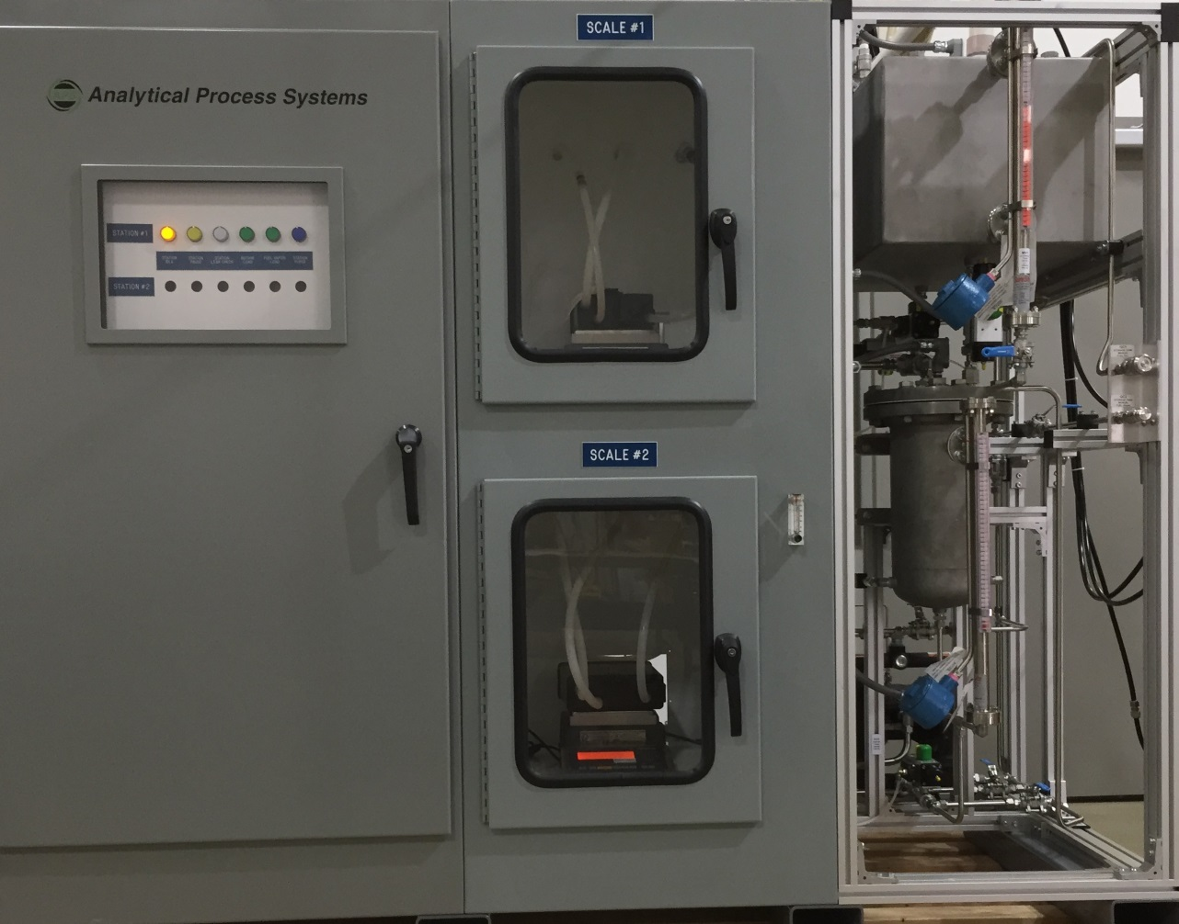

***Analytical Process Systems***

www.aps-mich.com

1771 Harmon Road

Auburn Hills, Michigan 48326

ph.(248)393-0700

**Table of Contents**

1.0 Introduction 3

2.0 System Specifications 4

Specification of System Capabilities 4

Specification of Major Components…………………….……………………………………………...…..5

Specification of Facility Requirements...……………….……………………………………………...…..5

3.0 Navigation of the System 6

System Overview 6

Menu Bar 7

Tool Bar………….……..……………………………….…………………………………………………..9

Alarm Status Bar **Error! Bookmark not defined.**

Event Message Bar **Error! Bookmark not defined.**

Purge Air Status Bar **Error! Bookmark not defined.**

4.0 Testing Methods 12

Single Scale with Stand Alone Canister Method………………………………………...………...….......12

Single Scale with Service Port Method...……………….…………………………………………………13

Dual Scale Method…………………………………………………………..… 40

5.0 Preparing the Test System 19

Connecting a Canister in a Scale Bay..….………...……………………………………...………...….......15

Modular Connections for Dual Scale Test Method.……………………………………...………...….......16

Modular Connections for Single Scale Test Method ...................................................................................18

Modular Connections for 2 Shift Setup...………...……………………………………...………...…........19

6.0 Testing Features 20

Conducting a Dual Scale Test **Error! Bookmark not defined.**

Adding to/Modifying the Master Canister List **Error! Bookmark not defined.**

Adding to/Modifying the Master Recipe List 42

Adding to/Modifying Purge Profiles 44

Configuration Options 45

7.0 Reports / Report Generation 57

Summary Report 57

Detail Report 57

File Naming Format 58

Report Files 58

Database Files 58

Generating Reports 58

8.0 Hot Keys 600

9.0 Spare Parts and Maintenance Schedule 61

10.0 Legal 62

**Appendix A Out of Tolerance (OOT) Determination 63**

**Appendix B Summary Data Collection 64**

**Appendix C Moisture Calculation 65**

**Appendix D Password Access Maintenance 66**

**Appendix E Terminology 68**

#### 1.0 Introduction

The Canister Preconditioning System (CPS) has been specifically developed by Analytical Process Systems to meet the requirements for evaporative emissions canister testing. Using customer-supplied butane and nitrogen cylinder gases and/or gasoline, standard and custom blended canister loading may be accomplished automatically with minimal user intervention. This makes it possible to initiate a test let Analytical Process Systems’ CPS software program perform load and/or purge testing on a variety of in-use and development canisters.

The CPS provides up to nine stations and four shifts for the Purging and Loading of activated carbon canisters. The CPS monitors all activity on the Canister Preconditioning System and automatically generates reports of that activity. Reports are stored locally on the CPS’s computer and may be manually or automatically sent to a local or network printer. Test reports may also be transferred to a host computer for analysis, long-term storage, and archiving. The system generates four types of reports for each process that has completed: a *Detail Report*, a *Summary Report*, a Microsoft Access® Database File, and an Excel report file. Additional reports are also available. These include recipes, system configuration, and alarm logs. The operator interface is keyboard and mouse. The menus follow the traditional Windows format, starting with a *Main Menu* on the *System Overview* screen, with sub- menus which allow access to particular functions. The *System Overview* screen provides a summary display of all activity on the system. *Detail Screens* for each station provide all operational information for the station and allow entry of test related data that is printed on all reports. This data includes items such as the vehicle number, engineer, canister information, technician, along with test comments. Additional operations include copying and printing reports, modification of tolerances and configurations for reports, viewing of recipes, viewing of the job list and other logs. Several of the operations available on the system are password protected to prevent use by unauthorized personnel. Items such as hardware configuration, setting of tolerances and exiting the software are functions restricted to users with sufficient password level.

#### 2.0 System Specification

***Specifications of System Capabilities***

Physical Characteristics: Approximate System Dimensions 78” (L) X 78” (H) X 36” (D)

Minimum Scale Bay Dimensions 700mm(L) X 500mm(H) X 500mm(D)

Station(s) Single

Scale(s) Two

Fuel Tank Storage Capacity 35 Gallons

Vapor Tank+Head Space Capacity 2 Gallons

Modular No, Internal Plumbing

Shift 1

Performance Characteristics: Pressure Decay Settings: Fill Time (0-999 seconds)

Hold Time (0-999 seconds)

Pressure Set Point (0-15 PSI)

Allowable Decay (0-100%)

Load Methods: Load by Time

Load by Weight

Load by Breakthrough

Load by Working Capacity multiplier

Load Rates: Fuel Vapor 40-80 grams/hr

Butane/N2 10-150 grams/hr Purge Rate 5-80 slpm

Configurable Dwell Time 0-9999 minutes

Scale Capacity 0-6000g

Scale Resolution 0.01g

Canister Working Capacity 25-500g

***Specifications of major components***

Alicat mass flow controllers/meters, accuracy = +/-(0.8% reading + 0.2%F.S.) @STD conditions of 1 Atm, 20oC

Vaisala HM120 temperature/humidity meter, accuracy = 0.2oC/1.5%R.H.

Gems tank level transmitter, accuracy +/- 1% of 16 mA

Sartorius Signum 3 Laboratory Balance accuracy(linearity) = 1.5 grams

Setra Model 278 Barometer non-linearity = 0.4 hPa

***Specifications of Facility Requirements***

Utilities: 120 VAC, 20 Amp, single phase AC Mains power, connected through disconnect.

Clean, dry compressed “shop” air, 90 PSIG delivery pressure., 20 SCFM

Compressed gases: pure nitrogen (purge air)., 99.5% Instrument Grade butane

Gasoline or other compatible testing fuel for live fuel vapor loading

All electrical components & wiring rated Class 1, Div. 1 Housed in Class 1, Div. 1 Rated Enclosure.

#### 3.0 Navigation of the System

**System Overview**

When the software is launched, after a brief system check and initialization, the System Overview Screen will appear on the computer. The System Overview Screen provides a summary display of the status of all stations and alarms. All the major components of the system can be accessed from the Menu Bar which is located along the top of this screen or the Tool Bar which is located underneath the Menu Bar.

Menu Bar

Tool Bar

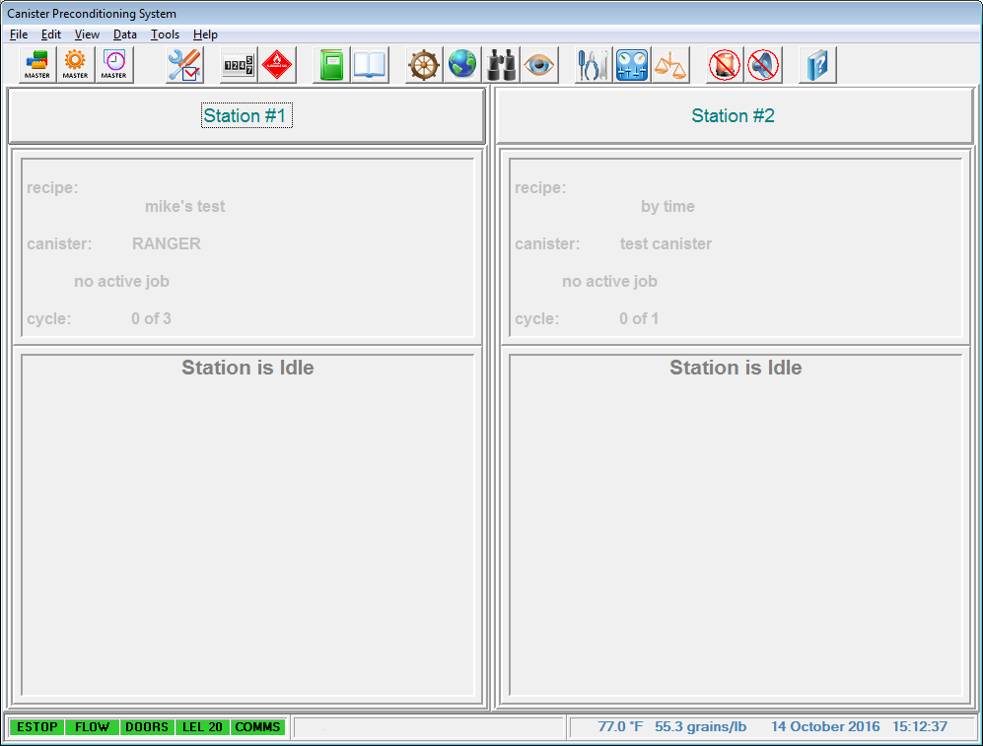

**Overview Screen**

Event Message Bar

Purge Air Status Bar

Alarm Status Bar

###### 

###### Menu Bar

The Menu Bar consists of the following commands:

File: Login

Logout

Copy Files

Print Files

Exit Program

Edit: Canisters

Recipes

Purge Profiles

Configurations

View: Air Log

Butane Available

Event Log

File Maintenance Log

Fuel Consumption Log

This command brings up the Login Window. From this window the user may change the logged in access account.

This command logs out the current user. For continued use of the system an access account must be logged in to return to the system overview.

This command opens the copy file utility. Note that multiple files may be copied at one time, however folders may not be copied or created.

This command opens a file print utility. Note Print Setup should be defined before selecting the print command.

This command shutdowns the canister testing software. This is the only way to shutdown the program properly.

This command provides a list of predefined canisters.

This command provides the interface to set up test recipes for Leak Checks, Loading and Purging.

This command provides a list of predefined purge profiles.

This command provides the interface to set up test and data acquisition conditions.

This command provides a table and graph of the monthly temperature, humidity, and barometric pressure each day.

This command provides an estimate of Butane available in current cylinder based on weight and test usage.

This command provides access to the system event log.

This command provides access to the file maintenance log.

This command provides a table and graph of the monthly Butane and Live Fuel Consumption per day.

Job List

Data: Review Data

Watch Current Data

Tools: Calibration

I/O Monitor

Scale Monitor

Help: Operator Manual

FirstAid File Save

About CPS release7

This command provides a list of completed jobs and the ability to generate reports.

This command allows current test data under 1000 samples to be viewed. Larger sample sets are exported in text format.

This command allows viewing of the last 10 sensor readings.

This command allows calibration of the mass flow controllers, analog inputs, and scales.

This icon allows the user to monitor and change I/O values.

This command allows the changing of scale type and Comm port assignment. The scale’s current value is also displayed.

This command launches the OperatorManual.pdf for the operator’s reference.

This command launches the a utility to create a zip file consisting of all necessary files need for APS assisted troubleshooting.

This command will open the about window, which contains system information such as the software version.

###### Tool Bar

The Tool Bar consists of the following Icons:









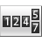















Master Canisters: This icon provides a list of predefined canisters.

Master Recipes: This icon provides the interface to set up test recipes for Leak Checks, Loading and Purging.

Master Purge: This icon provides a list of predefined purge profiles.

Configuration: This icon provides the interface to set up test and data acquisition conditions.

Fuel Consumption Log: This icon provides a table and graph of the monthly Butane and Live Fuel Consumption per day.

Butane Available: This icon provides an estimate of Butane available in current cylinder based on weight and test usage.

Event Log: This icon provides access to the system event log.

List of Jobs: This icon provides a list of completed jobs and the ability to generate reports.

Station Details: This icon provides access to station details and testing control functions.

Overview: This icon returns the user to the overview screen.

Review Data: This icon allows current test data under 1000 samples to be viewed. Larger sample sets are exported in text format.

Watch Data: This icon allows viewing of the last 10 sensor readings.













Calibration: This icon allows calibration of the mass flow controllers, analog inputs, and scales.

I/O Monitor: This icon allows the user to monitor and change I/O values.

Scale Monitor: This icon allows the changing of scale type and Comm port assignment. The scale’s current value is also displayed.

Turn Off Beacon: This icon turns off the alarm beacon.

Silence Horn: This icon silences the alarm horn.

.

Operators Manual: This icon launches the OperatorManual.pdf for the operator’s reference.

###### Alarm Status Bar

The Alarm Status Bar displays the condition of Alarms on the Butane Loader. Green indicates the normal operating condition, Yellow is for warning, and Red indicates the Alarm condition is active.

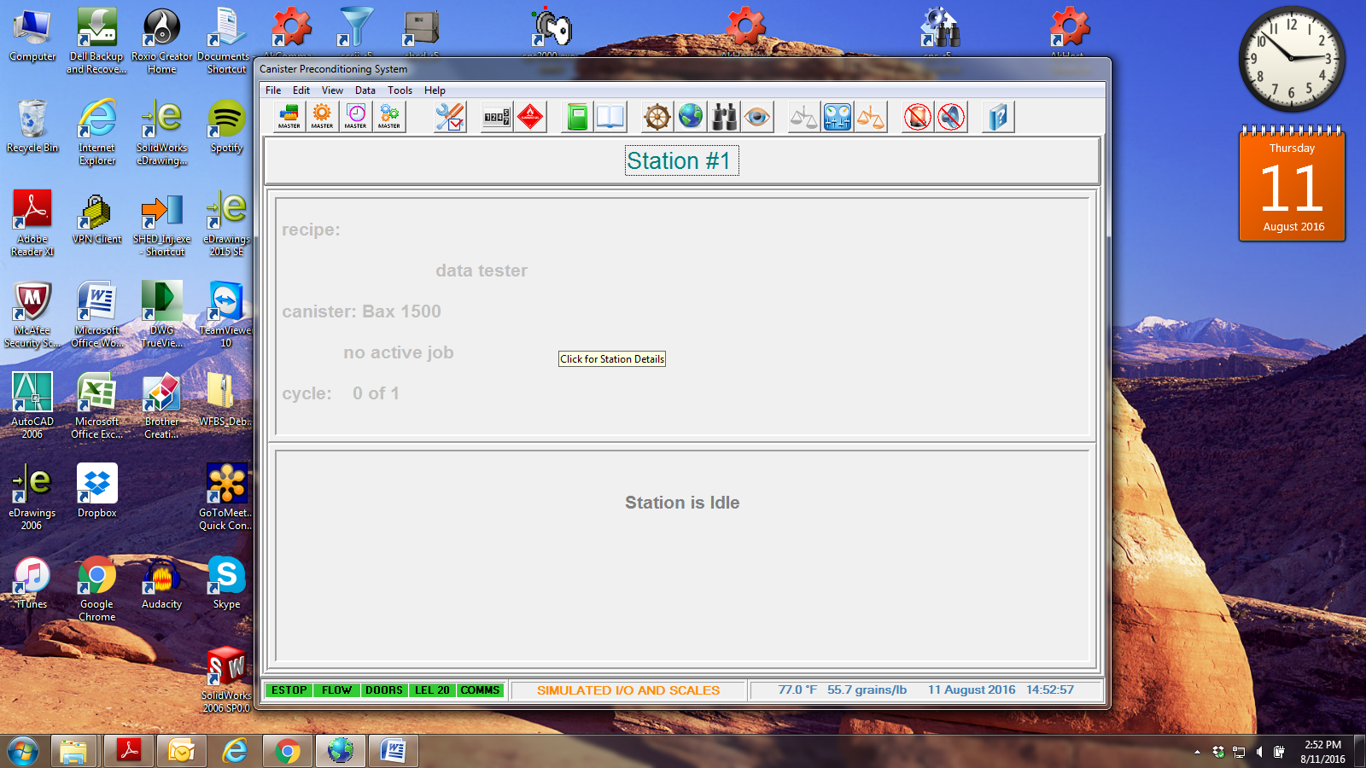

*The following conditions are monitored:*

E-stop Emergency Stop

Flow Cabinet Exhaust Flow Switch

Doors Cabinet Door Switches (optional)

LEL-20 Hydro Carbon Vapor Concentration Alarm, 20 Percent Lower Explosive Limit

Comms PC Communications Status

###### Event Message Bar

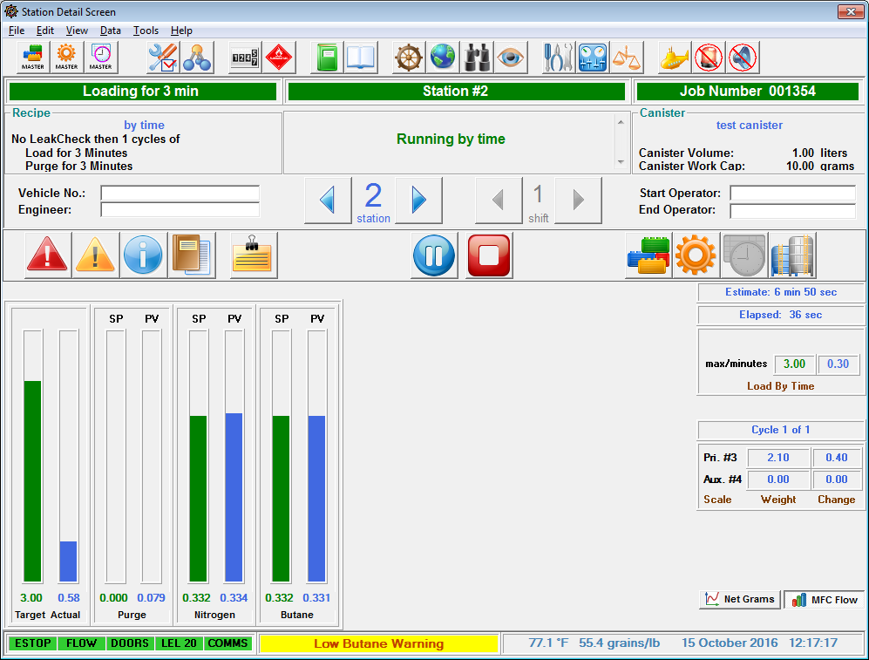

An example of a populated Event Message



An example of a blank Event Message

The Event Message Bar displays a text message about most current event or alarm currently occurring. Alarms will take high precedence over events. When there are no current events this field is blank.

###### Purge Air Status Bar



The Purge Air Status displays the Temperature and Moisture level in the area of the system installed in addition to the date and time of the computer’s real-time clock. If the Purge Air System (PAS) option is installed, both temperature and moisture readings are obtained from the PAS directly. Humidity will be displayed in either grains/lb or % rH units. These conditions are read when any station is in the Purge Mode to determine if Purge Air conditions are within desired tolerance. Current values are displayed on both the Overview Screen and the station Detail Screen.

Absolute Moisture is provided in grains per pound (or % rH if desired), the units used by the EPA and CARB to specify the moisture conditions required. The Absolute Moisture level is calculated using temperature, relative humidity and barometric pressure, see Appendix C for the actual calculation formula. The current values of temperature, relative humidity and barometric pressure are displayed on the Common I/O Monitor screen.

#### 4.0 Testing Methods

There are two different methods for canister weight monitoring – Single Scale Method and Dual Scale Method. The Single Scale Method is only monitoring the weight gain on the auxiliary (secondary) canister while the Dual Scale Method is monitoring the weight gains on both (primary and auxiliary) canister. The single scale method may be connected to either a stand alone canister or an in-vehicle canister. *Note:* The pictures depict a typical modular canister preconditioning system. Your canister preconditioning system may not match the following illustration.

###### 

###### Single Scale with Stand Alone Canister Method

With this connection arrangement, the auxiliary canister is the only unit placed in the scale bay and the system is only monitoring the weight gain on the auxiliary canister. This method is for use on Modular Canister Preconditioning Systems.



###### Single Scale with Service Port Method

This method is for in-vehicle canister with connection via the service port. The system only monitors the auxiliary canister in the scale bay. This method is for use on Modular Canister Preconditioning Systems.



###### Dual Scale Method

With this connection arrangement, both primary and auxiliary canister units are placed inside their own scale bay separately and the system is monitoring the weight gain for both canisters. This test method is for use on both Modular and Non-Modular Preconditioning Systems.

###### `

LEAK CHECK

STATION #1

PAUSE

LOAD

PURGE

IDLE

SCL-1

IDLE

LEAK CHECK

PURGE

LOAD

PAUSE

STATION #2

SCL-2

SCL-3

PURGE

STATION #3

PAUSE

LOAD

LEAK CHECK

IDLE

AUX

PRIMARY

CANISTER

LOAD

VENT

PURGE

AUX

CANISTER

#### 5.0 Preparing the Test System

The APS Canister Preconditioning System with Live Fuel and/or Butane loading capabilities, utilizes stainless steel fuel storage tank(s) which hold the test fuel used during fuel vapor loads. The upper storage tank holds approximately 30+ gallons of fuel (plus head space), and the vapor generator tank holds approximately 2+ gallons. During live fuel vapor generation, the vapor tank is filled from the above storage tank to approximately 1+ gallons, allowing for head space. A combination of level indicators and level switches, wired through appropriate Intrinsic Safety Barriers, allow safe and automatic fuel tank level management under control of the CPS computer. Additionally, manual draining and filling is available to the operator via several hand valves which area clearly labelled. A quick glance at the fuel storage tank sight glass should give the operator a rough idea of available fuel and whether or not additional fuel is required for the test. If the fuel storage tank level sensors are setup refueling will be automatic. Additionally if Live Fuel is not currently being used the vapor tank sight glass should read low. Your canister preconditioning system may not match the following reference pictures.

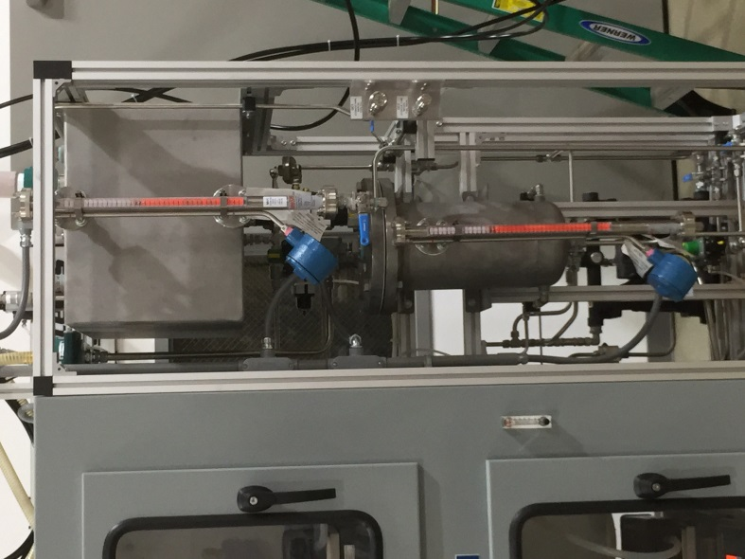

Vapor Tank

Level

Fuel Vapor

Generator Tank

Fuel Storage

Tank

Storage Tank

Level

Tank

**Please ensure all fuel containing vessels are properly grounded to prevent static discharge during fuel transfer operations.**

###### Connecting a Canister in a Scale Bay

Connect the canister with the provided Load, Purge, and Vent hoses. The canister should have two ports near each other and a third port that is isolated. The isolated port should connect to the Vent hose. The Load port should be identified by a gas pump icon or similar. If it is unlabeled the larger of the remaining ports is usually the Load port. Lastly connect the purge hose to the remaining port. For a Non-Modular system, setting up two canisters in this method is all that is required.

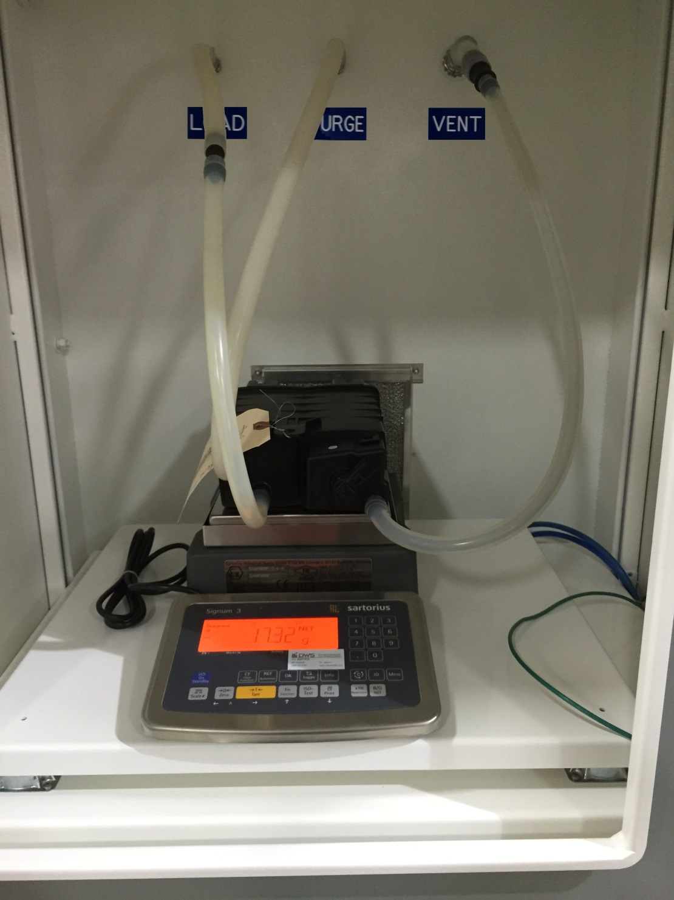

Typical Canister connected in a Scale Bay.

###### Modular Connections for Dual Scale Test Method

Modular Canister Preconditioning systems are most commonly identified by several quick connects on the front of the system. There should be one set of quick connects associated with the scale bay and another set associated with the test station. Lastly connect the Aux Load port of the Primary canister to the Load port of the Auxiliary Canister.

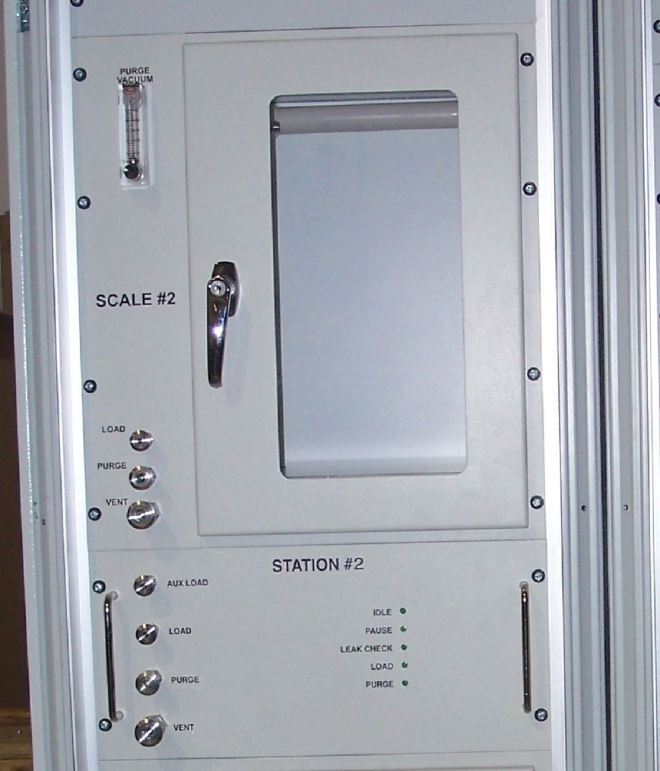

A typical Modular Station and Scale Bay

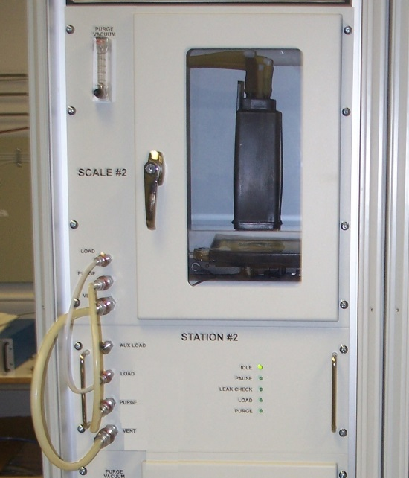

For the primary canister Scale Bay connect the Station ports to the matching Scale Ports.

(Load – Load, Purge – Purge, Vent – Vent)

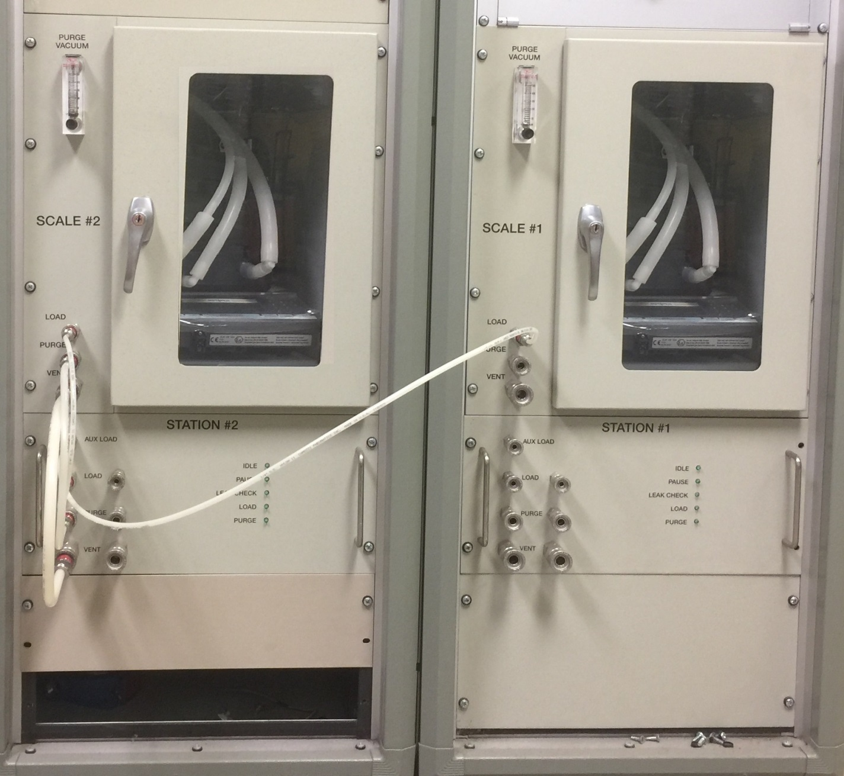

Lastly connect the Aux Load Port of the Primary canister to the Load Port of the Auxiliary Canister.

###### Modular Connections for Single Scale Test Method

Similar to the Dual Scale Test Method connect the Aux Load port of the Station to the Load port of the Auxiliary Canister. Connect the Station ports to either a sand alone canister or in-vehicle canister. The completed setup should be similar to the following picture.

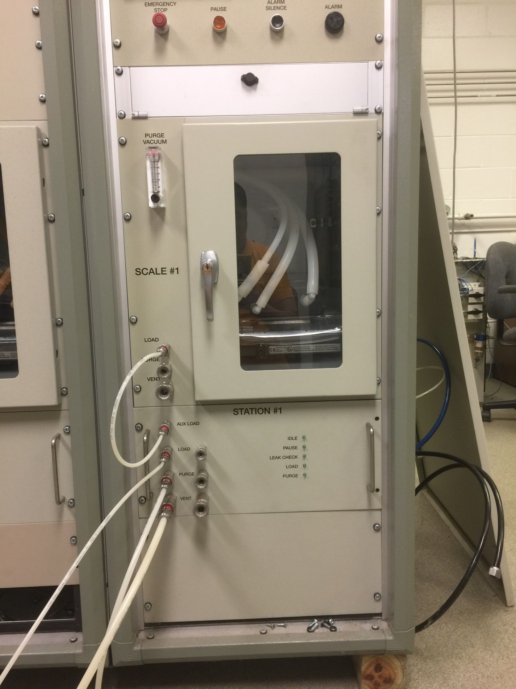

Typical single canister connection

#### 

###### Modular Connections for 2 Shift Setup

Stations with two pairs of Load, Purge, and Vent ports are capable of a 2 shift setup. A 2 shift setup provides the capability of queuing multiple tests in a job list you may connect multiple canisters to a station. The benefit of a 2 shift setup is that the system can automatically start the next test in the job list without immediate user intervention.



Typical 2 Shift Port Pair

#### 6.0 Testing Features

###### Conducting a Dual Scale Test

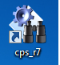Launch the CPS_r7 application by double-clicking on the desktop icon.

A software launch screen will appear, as shown below:

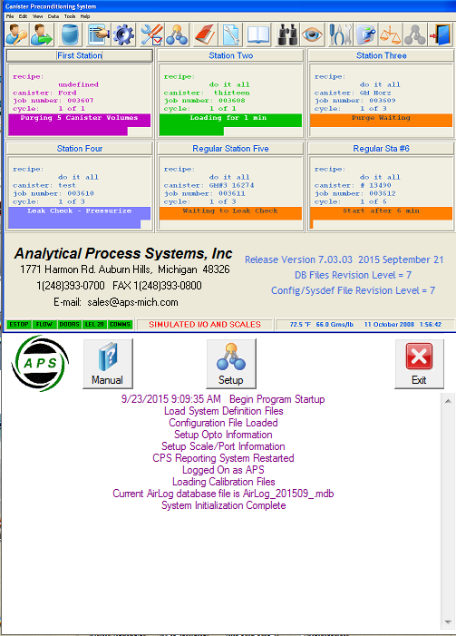

CPS Launchscreen

The launch screen shows the software version number, and other pertinent information. It is also possible to open the Operator’s Manual from the launch screen. Once system components have loaded the Overview Screen will be launched.

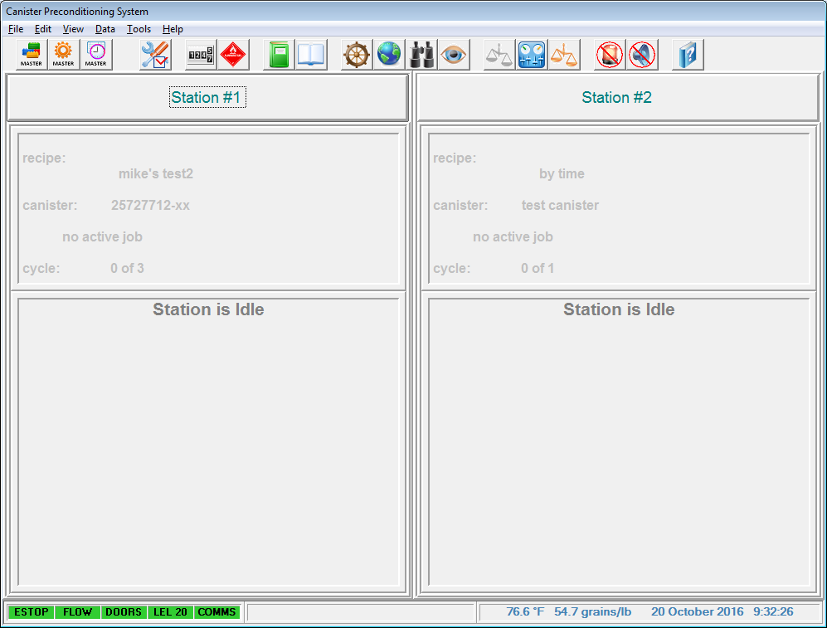

Typical Overview Screen

###### 

###### To begin configuring the test, click anywhere in the Station Area. This will open the Station Detail Screen.

###### 

Example: Station #1 Area highlighted in RED.

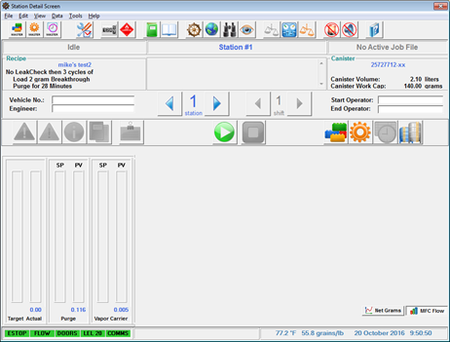

Typical Station Detail Screen

First select the canister parameters. This is done by clicking on the Station Canister icon. This will bring up the Station’s Canister Properties.

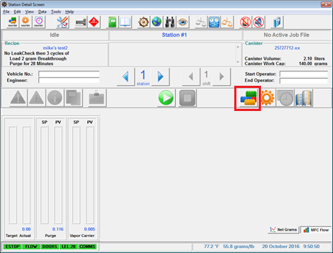

Station Canister Icon Highlighted in RED.

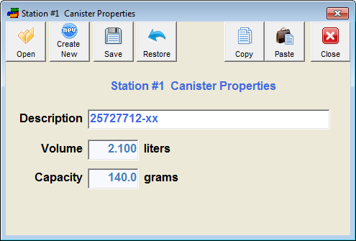

Open a predefined canister by clicking the Open Icon. This will open the master list of predefined canisters. If the user wishes to define a canister, click on the Create New Icon. Enter a Description, Volume, and Capacity.

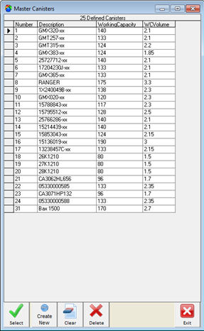

Click on the canister you wish to load setting for. Verify user choice by clicking the Select Icon. This will close the Master Canister List Window.

Click Save to Load the Canister Data to the Station. Click the Close Icon to exit canister properties. Note: the Save Icon only transfers the settings to the appropriate station. To Save the Canister Properties it must be defined using the Master Canister Icon. You can verify your selection is loaded by checking the canister window.

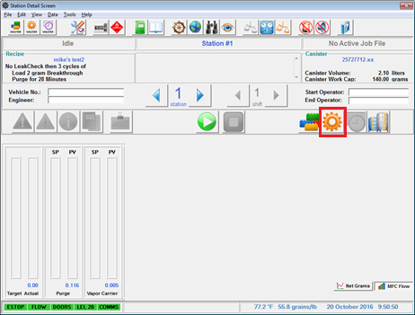

Next Click the Station Recipe Icon. This will bring up the Station’s Recipe Parameters.



Station Recipe Icon Highlighted in RED.

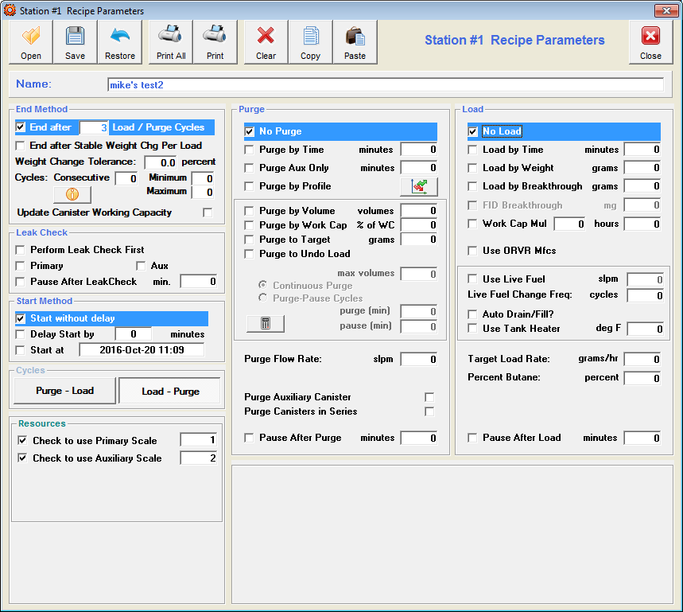

Typical Station Recipe Screen

In general the Recipe Parameters are divided in to 5 sections. First a test type needs to be decided. Either a Leak Check and/or Purge and/or Load parameters must be defined. Without selecting at least one type there is no test to run.

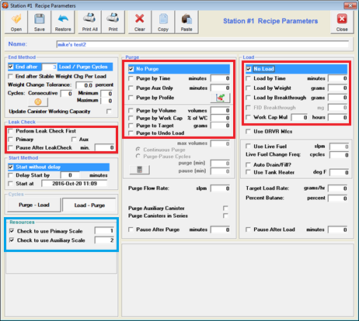

Station testing types Highlighted in RED. Scale Bay assignments Highlighted in BLUE.

If the operator is running a non-modular system Primary and Auxiliary Scales will automatically be assigned. If you are running a modular system these assignments should be checked for accuracy. Click on the “Perform Leak Check First”, “Primary”, and “Aux” boxes. These settings order the system to leak check both canisters before starting the test.

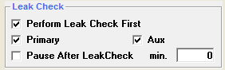

Next select purge settings. If Purge by Profile is selected the Purge Profile may be access via either the button next to the check box or by the Purge Profile Icon on the Station Detail Screen. Click on the “Purge by Profile” box.

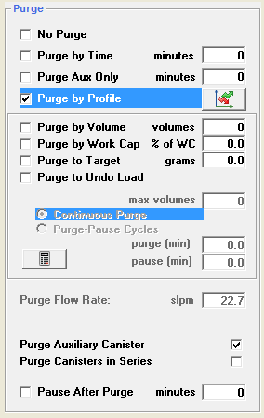

Now select Load settings. Click the “Load by Breakthrough” box. Enter “2” for the grams value.

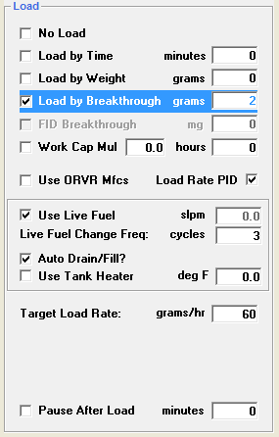

Once the test type(s) is/are selected any associated starting and ending conditions must be specified.

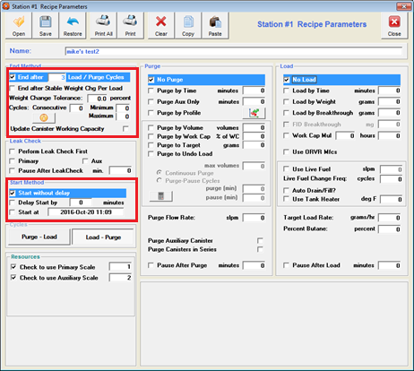

Station testing start/end options Highlighted in RED.

Define the End method. Click the “End after ___ Load/Purge Cycles” box. Enter “3” as the ___ cycle value.

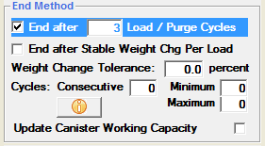

Define the Start method. Click the “Start without delay” box. This will immediately begin the test once the test start button is clicked.

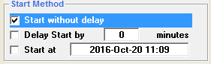

Transfer the Recipe to the Station by click the Save Icon. A confirmation and Test Duration Estimate should appear toward the bottom of the Station Recipe Parameters.

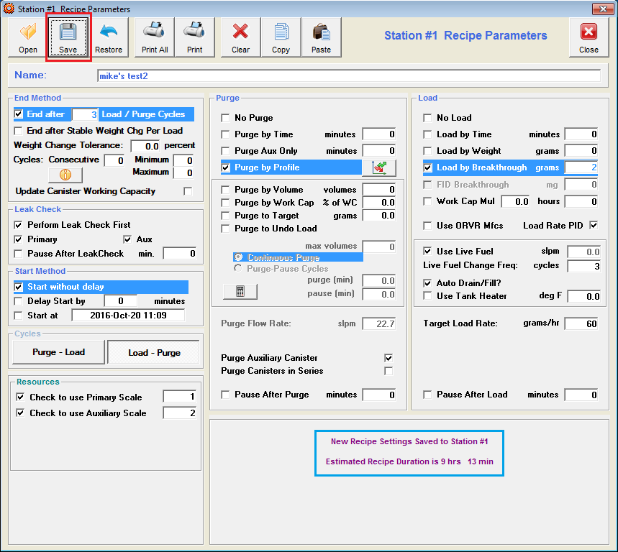

Save Icon Highlighted in RED. Recipe Confirmation and Test Duration Estimate Highlighted in BLUE.

Click on the “Close Icon” to Exit the Station Recipe Parameters.

Upon returning to the Station Detail Screen the operator should notice the Purge Profile Icon is now active. Click on the Purge Profile Icon.

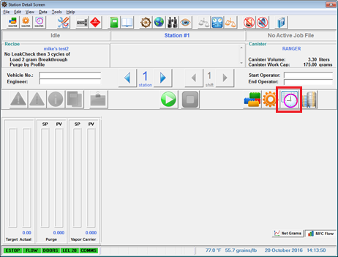

Purge Profile Icon Highlighted in RED

Once the Station Purge Profile has opened, click on the “Open” icon. This will launch the Master Purge Profiles Window.

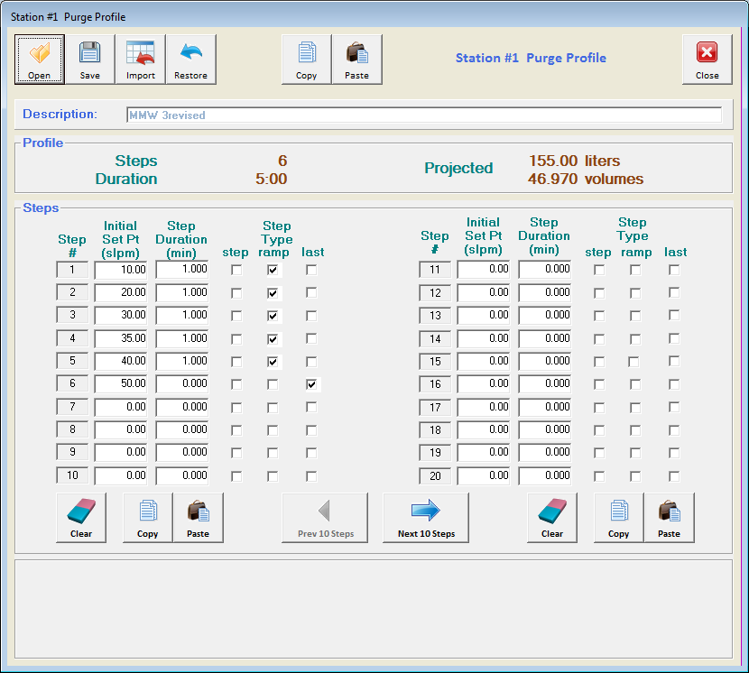

In the Master Purge Profiles Window select a profile by click either a number or description, select Master 2. Click on select to confirm the selection. The system will close the master purge window upon confirmation.

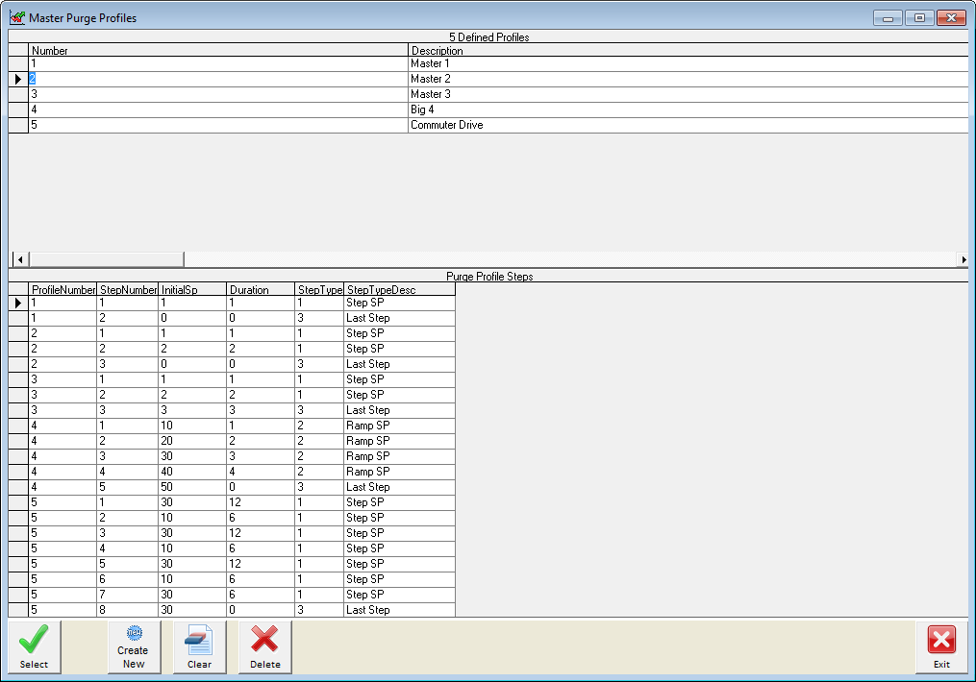

Click save on the Station Purge Profile Window to transfer the settings to the station. Once complete, click the close icon to exit the window.

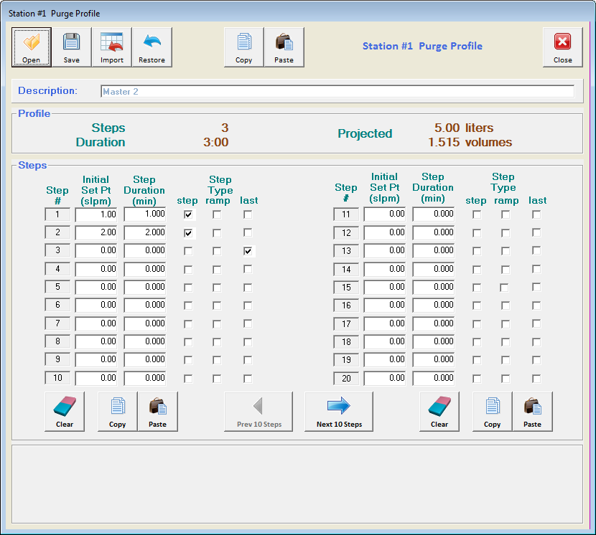

At this point the operator has set all the conditions to begin a test. To begin the test the operator needs to click the start icon.

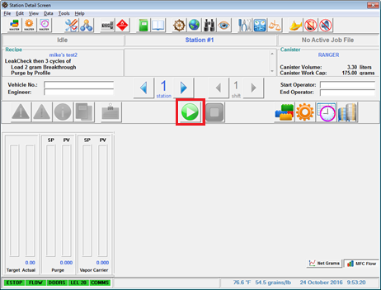

Immediately the Leak Check for the primary canister will begin. The canister pressure set point will attempt to match the target value and hold. This Value can be found by clicking the Configuration Icon under Leak Check.

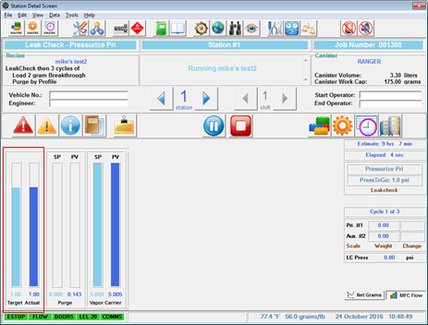

Canister Pressure bar graph in RED.

Automatically after the primary canister pass the leak check the auxiliary canister will perform the same test. If both canisters pass leak check a test with the transferred test conditions will run.

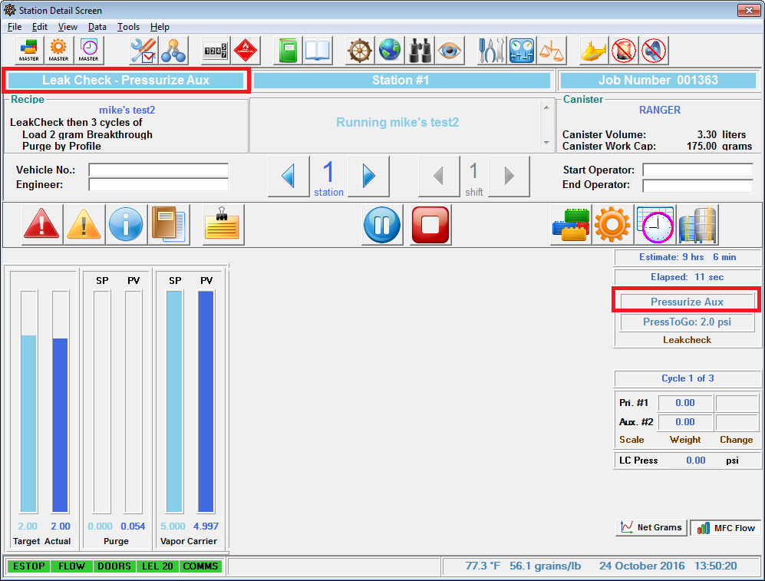

Identifiers to determine whether Primary or Aux is being tested in RED.

Once the Leak Check is complete the system will begin the Purge-Load or Load-Purge Cycles. A purge cycle can be identified by purple indicators.

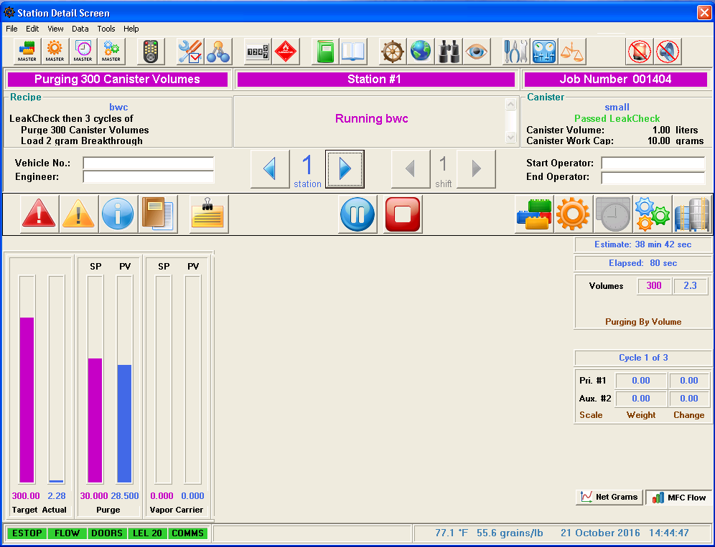

Typical Purge Cycle

A Load cycle can be identified by green indicators.

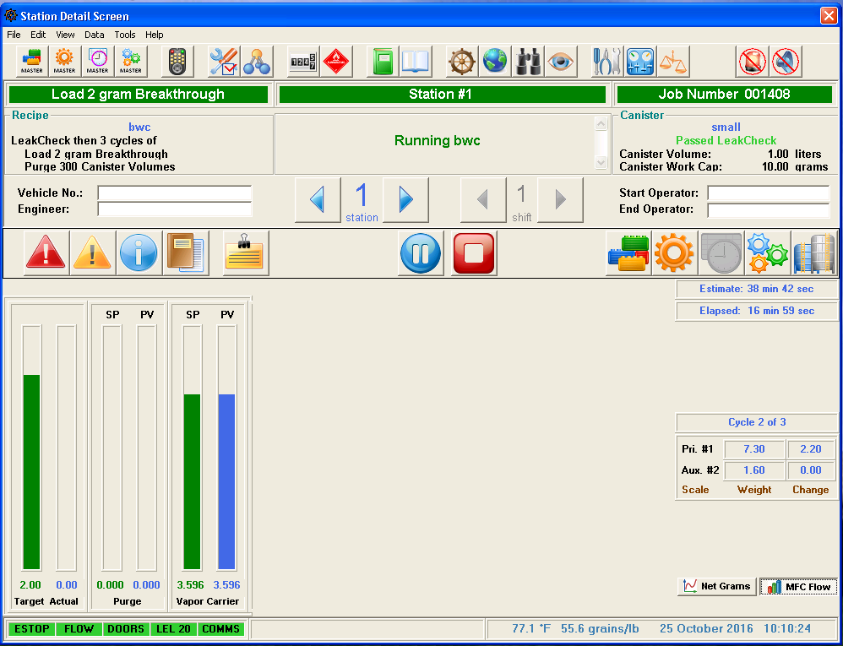

Typical Load Cycle

The test is complete once the Job events Log Reports.

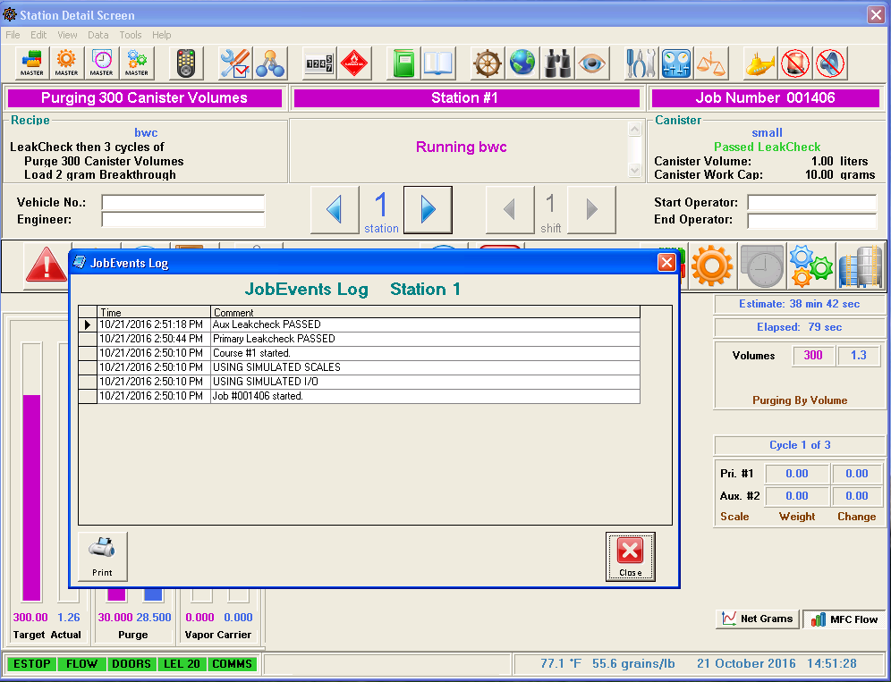

Typical Screen of completed test

Adding to/Modifying the Master Canister List

 Begin by clicking on the master canister icon. This icon will bring up the Master Canister List. Note the number column. New canisters will populate based on the next available number. Click the Create New Icon to define a new canister. This will open the Master canister Properties Box.



Here new canisters may be defined and existing canisters may be modified. Assign a description, volume, and capacity. Use the Arrow keys to change the number value. Click save when done. Note: unlike the Station Canister Icon clicking the Save Icon does not transfer the canister data but adds/overrides the data on the master list based on number.

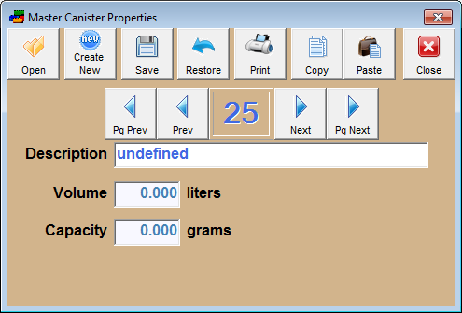

Note: Since the next available number was 25 that is where Master Canister Properties opened.

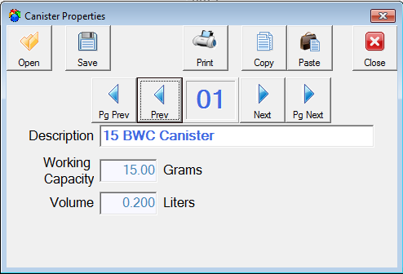

This window shows that the 15 BWC Canister and data will override GMX320-xx and data on the canister master list.

**Adding to/Modifying the Master Recipe List**

 Begin by clicking on the master recipe icon. This icon will bring up the Master Recipe List. Note the number column. New Recipes will populate based on the next available number or number with default values. Click the Create New Icon to define a new recipe. This will open the Master Recipes Parameters Window.

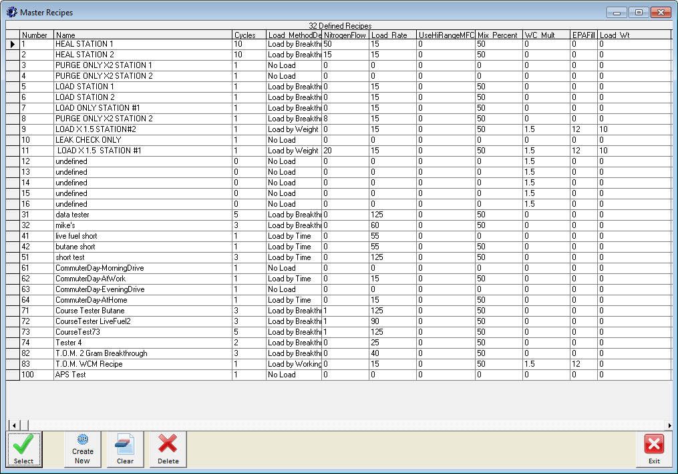

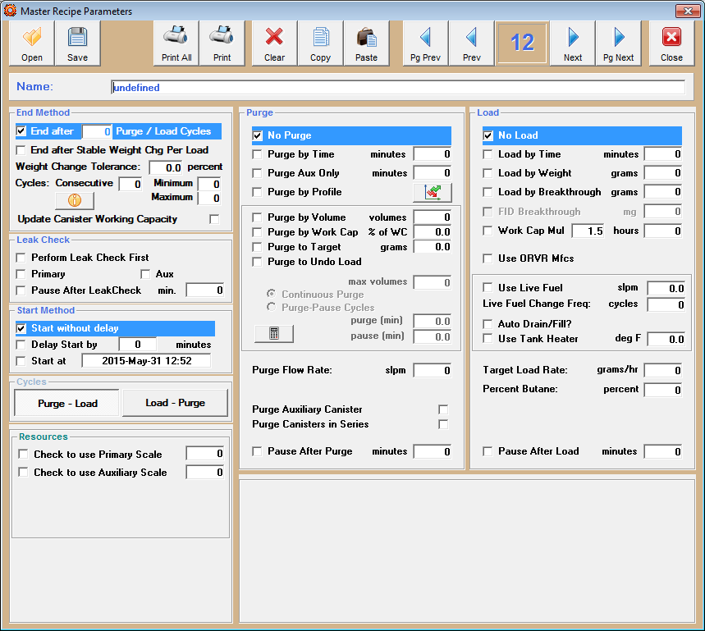

Master Recipe Parameters Window

On the Recipe Details screen, the user may set typical parameters for each phase of the canister tests – Cycle, Purge, and Load parameters, allowing maximum testing flexibility. Once changes have been made satisfactorily, clicking Save will store the settings to the Master Recipe database. When loaded as a Station Recipe, user selections are validity against the hardware present. Invalid entries will be highlighted in yellow. When all entries are correct, a message appears containing an estimate of the time required to execute the user’s test.

**Adding to/Modifying Purge Profiles**

 Begin by clicking on the master purge profiles icon. This icon will bring up the Master Purge Profiles. Note the number column. New Purge Profiles will populate based on the next available number or number with default values. Click the Create New Icon to define a new recipe. This will open the Master Recipes Parameters Window.

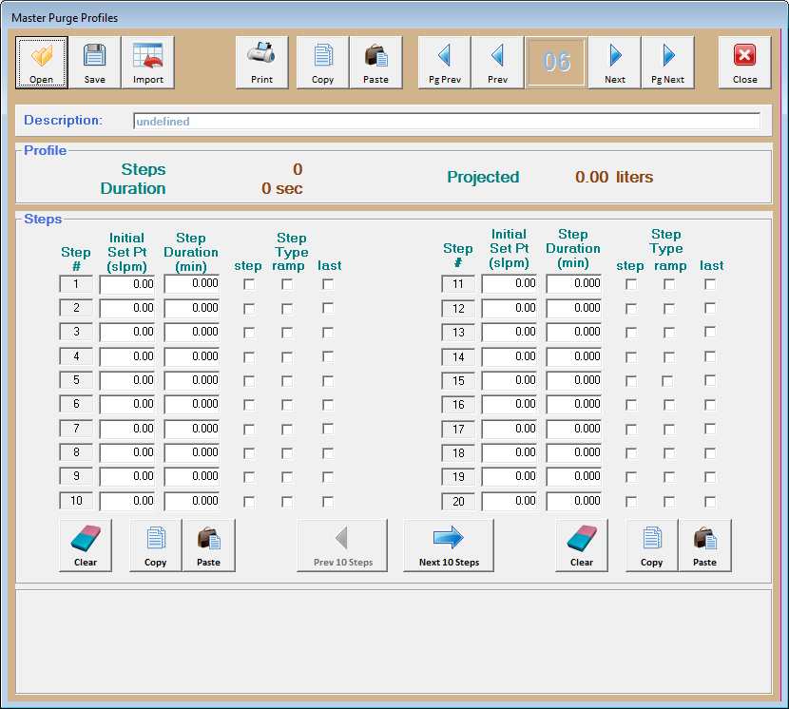

This CPS feature allows the user to purge a canister using a custom profile of the desired purge rate vs. time. The user enters a series of steps, indicating each step’s flow rate, duration, and step transition mode. Clicking Save will store the settings to the Master Purge Profile database.

**Configuration Options**

 Begin by clicking on the Configuration icon. This icon will bring up the Configuration Options Screen. The Configuration Options Screen allows for changes to test/report conditions, tolerances, and documentation of job details. Clicking the save icon transfers this data.

Leak Check Options

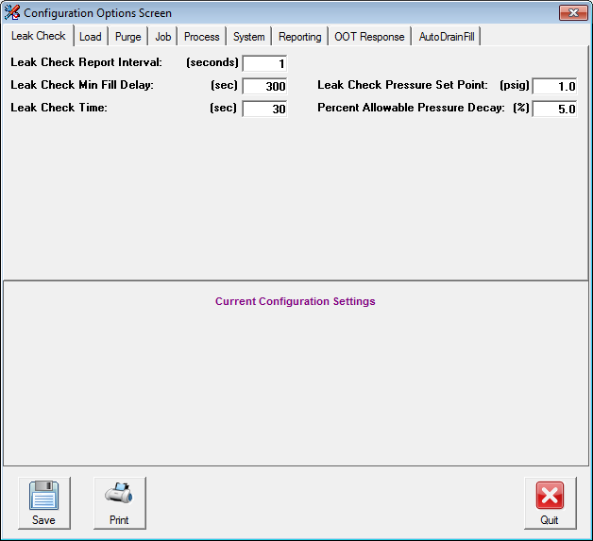

Leak Check Report Interval

Leak Check Min Fill Delay

Leak Check Time

Leak Check Pressure Set Point

Percent Allowable Pressure Decay

Specifies the time for the detail report interval.

Specifies the time for the stations to achieve the required pressure during the leak check.

Specifies the time for the stations to maintain the pressure (Leak Check Pressure Set Point), applicable with pressure decay (% Allowable Pressure Decay) factor.

Specifies the desired leak check pressure.

Specifies the percentage of pressure decay allowable within the leak check time specified.

Load Options

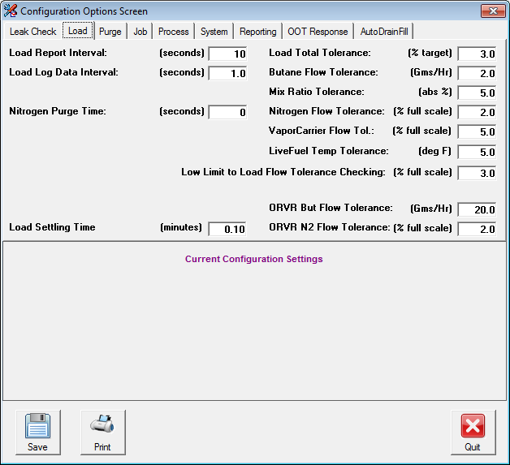

Load Report Interval

Load Log Data Interval

Nitrogen Purge Time

Load Total Tolerance

Butane Flow Tolerance

Specifies the update interval for the Detail Report during Load cycles.

Specifies the update interval for the Database file during Load cycles.

Time for N2 pre-flow prior to each Load cycle.

Specifies the tolerance for the Load Cycle total, with relation to the target. The value represented by the Load Cycle target may vary, depending upon the Load method selected. (i.e., it could represent total butane, or could represent total time)

Specifies the allowable load rate tolerance for the Butane Mass Flow Controller.

Mix Ratio Tolerance

Nitrogen Flow Tolerance

Low Limit to Load Flow

Tolerance Checking

Load Settling Time

Purge Options

The Canister Preconditioning System monitors the ratio of Butane to Nitrogen in % Butane. This tolerance represents the tolerance for the mix ratio.

Specifies the allowable flow rate tolerance for the Nitrogen Mass Flow Controller.

This value specifies the low limit for the Load Flow checking. Load Flow values below this setting are truncated to zero to prevent system noise.

Time after completion of cycle before readings are taken from scale(s).

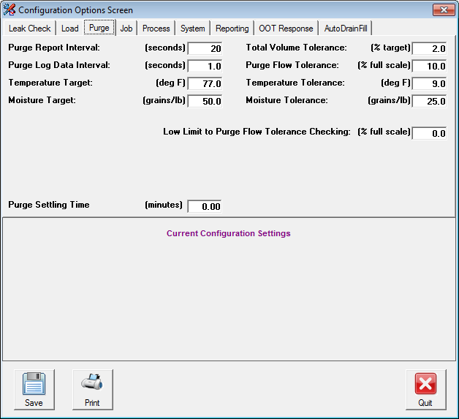

Purge Report Interval

Purge Log Data Interval

Specifies the update interval for the Detail Report during Purge Cycles.

Specifies the update interval for the Database file during Purge cycles.

Temperature Target

Moisture Target

Total Volume Tolerance

Purge Flow Tolerance

Temperature Tolerance

Moisture Tolerance

Low Limit to Purge Flow Tolerance Checking

This value indicates the target temperature value for the Purge Air.

This value indicates the target moisture value for the Purge Air.

This value specifies the tolerance for the total Purge Process. The actual total volume flowed is compared to the Target and must be within this tolerance.

This value is the tolerance for the Purge Air Flow Control.

This value indicates the temperature tolerance values for the Purge Air. The system only monitors Purge Air for an Out Of Tolerance condition when the station is actually performing a purge operation.

This value indicates the moisture tolerance values for the Purge Air. The system only monitors Purge Air for an Out Of Tolerance condition when the station is actually performing a purge operation.

This value specifies the low limit for the Purge Flow checking. Purge Flow values below this setting are truncated to zero to prevent system noise.

Job Options

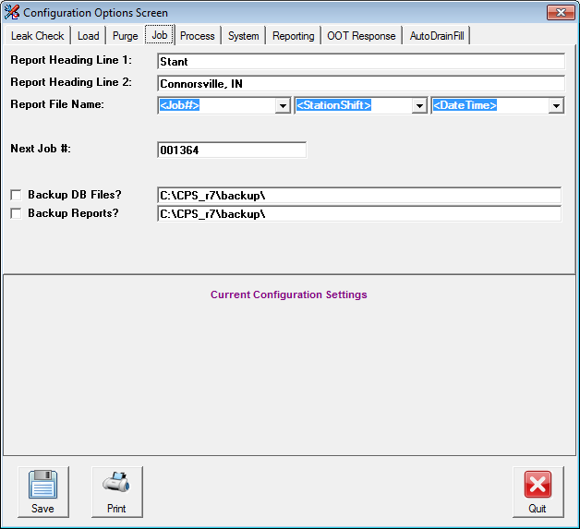

Report Heading Line 1

Report Heading Line 2

Report File Name

Next Job #

Backup DB Files

Backup Reports

This heading entry permits the operator to enter custom headings that are printed on the reports.

This heading entry permits the operator to enter custom headings that are printed on the reports.

These fields allow operator to customize the format of the file names to be used for the reports.

Enter the next job/report sequence number to be used. The system will increment this field by 1 for each new job.

Check this field and specify the locations if duplicate copies of the database files and/or reports are desired.

Check this field and specify the locations if duplicate copies of the database files and/or reports are desired.

Process Options

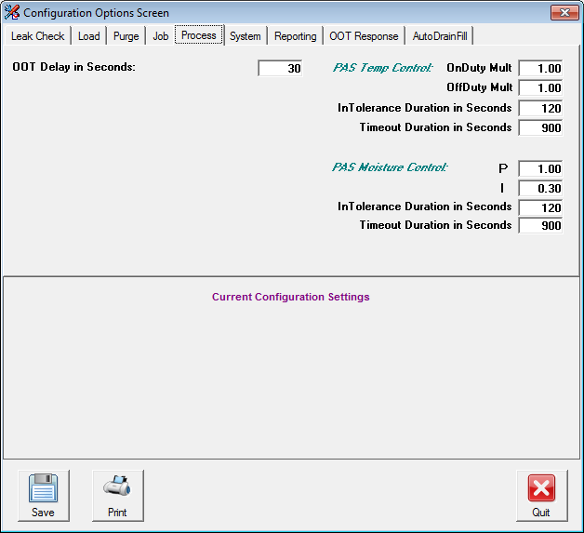

OOT Delay in Seconds

OnDuty Mult

OffDuty Mult

Temp In Tolerance Duration in Seconds

Temp Timeout Duration in Seconds

This setting specifies the time duration required for any process value which is continuously beyond the tolerance setting to trigger the out of tolerance condition.

Purge Air System Heating element duty cycle on multiplier ratio.

Purge Air System Heating element duty cycle on multiplier ratio.

The time required to accept temperature has settled

The time allowed for temperature to be accepted as settled.

P

I

Moisture In Tolerance Duration in Seconds

Moisture Timeout Duration in Seconds

Moisture Proportional Gain

Moisture Integral Gain

The time required to accept moisture has settled.

The time allowed for moisture to be accepted as settled.

System Options

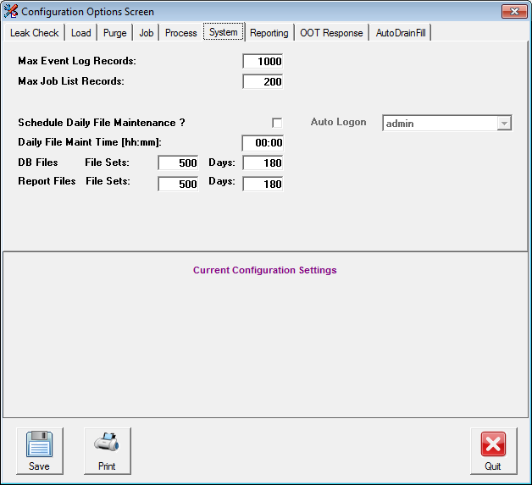

Max Event Log Records

Max Job List Records

Schedule Daily File Maintenance

Daily File Maint Time

DB Files File Sets

Report Files Sets

DB Files Days

Report Files Days

This sets the amount of events that can be saved in the log.

This sets the amount of jobs that can be stored in the job list.

This activates the file maintenance scheduler.

This sets the military time of when the file maintenance will run.

This sets the maximum number of database files. Quantities exceeding this number will be deleted based on oldest entry date.

This sets the maximum number of report files. Quantities exceeding this number will be deleted based on oldest entry date.

This sets the maximum number of days files will be stored. Files older than the specified days will be deleted during file maintenance.

This sets the maximum number of days reports will be stored. Reports older than the specified days will be deleted during file maintenance.

Reporting Options

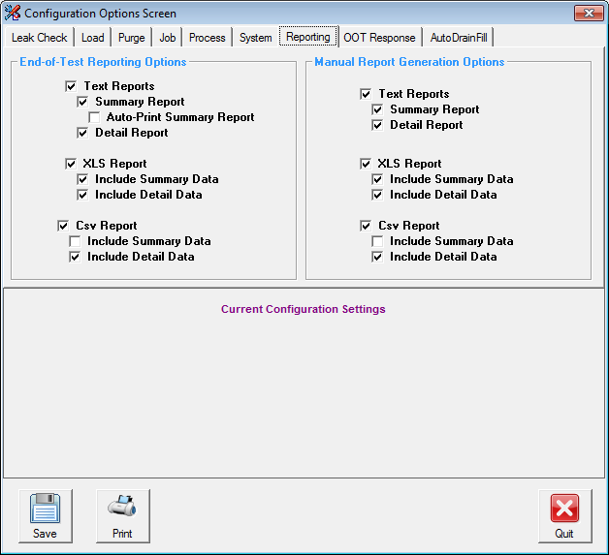

Reporting options allow selection of report formats for end of test and manual request as well as an automatic print function. When checked, these reports will be generated automatically by the CPS system’s computer, and be placed in the c:\cps_R5\reports folder. Manual reports are initiated by the user after the completion of a test, and may only be run while the CPS system is idle.

OOT Response Options

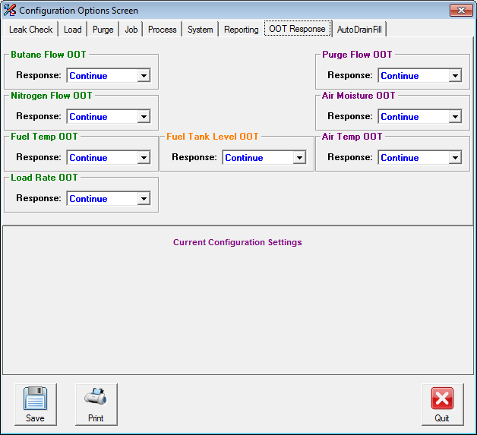

Controls the manner in which the system responds to the various Out-of-Tolerance conditions. Three responses are possible: Pause, Continue, or STOP. If set to Pause, the corresponding OOT condition will cause the system to halt, awaiting the user to press Continue. If set to STOP, the system will conclude the currently running test, generate reports, and only provide the option of aborting the test upon encountering the selected OOT condition. Setting to Continue causes the system to continue to execute, while capturing the OOT in the system’s Out-of-Tolerance log.

Auto Drain Fill Options

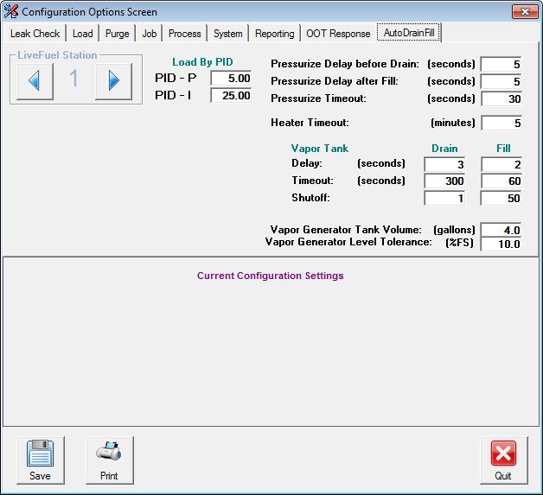

Load By PID-P

Load By PID-I

Pressurized Delay before Drain

Pressurized Delay after Fill

Pressurized Timeout

Heater Timeout

Load phase proportional gain

Load phase integral gain

Time pressure is maintained to dilute fuel vapor before drain. This acts to prevent large build ups of fuel vapor.

Time pressure is maintained to dilute fuel vapor after fill. This acts to stabilize load fuel vapor concentration.

Time allowed reaching specified pressure.

Time allowed for Heater Element in the Vapor Generation Tank to reach set temp.

Vapor Tank Drain Delay

Vapor Tank Drain Timeout

Vapor Tank Drain Shutoff

Vapor Tank Fill Delay

Vapor Tank Fill Timeout

Vapor Tank Fill Shutoff

Vapor Generator Tank Volume

Vapor Generator Level Tolerance

Time to delay the draining of Vapor Tank.

Time allow to drain vapor tank.

The acceptable vapor tank fill capacity in percent level 0-100 during drain phase

phase.

Time to delay the Filling of Vapor Tank.

Time allow to fill vapor tank.

The acceptable vapor tank fills capacity in percent level 0-100 during fill phase.

The physical volume of Vapor Tank.

Fuel level tolerance to full scale

#### 7.0 Reports / Report Generation

The Reporting System automatically creates reports for each process that is performed. These reports include the Summary Report(Notepad), the Detail Report(Notepad) and a Microsoft Access® database detail file. If selected in Configuration, an MS Excel report is also generated at the conclusion of the test. Reports appear in the path:

C:\cps_R7\reports

###### 

###### Summary Report

The Summary Report is a short report, 2 pages for every one to two cycles, that including the Header, Recipe, Start and End Barometric Pressure, Purge and Load Summaries and Alarm and Out of Tolerance Information. The Purge and Load Summaries include Minimum, Average, Maximum and Target values observed for flow rates and ambient conditions, and the Total Flow for each cycle.

###### 

###### Detail Report

The Detail Report is a much larger report that contains the Header, Recipe, Purge and Load Detail Sections, and Alarm and Out of Tolerance Information. The Purge and Load Detail Sections include pertinent process data taken at intervals specified in the System Configuration file during both the Purge and Load Processes.

###### 

###### File Naming Format

The file names for both Reports and Database are automatically assigned by the System with the following criterion:

Report Files

File Type: **ASCII Text**

Format: **<field1><field2><field3>nnnnnn_type.RPT**

*Filename Description*

<field1><field2><field3> These 3 separate fields are defined by the JOB function in the Configuration Screen

nnnnnn 6-Character Sequence Number (automatically incremented by 1 for each new job)

type Either “Summary” or “Detail”

RPT 3-character File Extension

Database Files

File Type: **Microsoft Access Database**

Format: **Cnnnnnn.mdb**

*Filename Description*

C File Prefix

nnnnnn Same 6-character Sequence Number defined by the Report System

mdb Microsoft Access Database File Extension

###### Generating Reports

The Reporting System will automatically assign a new report filename and begin logging data for a station whenever a new test is activated by a user. The corresponding filename will be displayed on the upper right corner of the Station Detail screen for the duration of the process.

During the process, the reporting system logs data to a Microsoft Access Compatible Database file. The filename will be *Cnnnnnn.mdb.* Where nnnnnn is the sequence number of the process. Operational data and comments may be entered or changed on the Station Detail screen at any time while the process is active.

Upon completion of the process and before the station has been returned to the IDLE mode, the Summary, Detail and Access reports are generated using data from the Database File. If the System Configuration is set to automatically print either the Detail or Summary report or both, the reports will be printed at this time.

**Note: If the system was shut down due to a power failure or a software crash, it will be impossible for the system to generate reports for all incomplete processes. If the Job List entry for a particular test is lacking a Stop Time, report generation will fail.**

At the end of the Data section for the Summary and Detail reports, the system prints a Completion Status line. This line will read either *Job Completed Normally*, or *Job Completed Abnormally.* This line indicates whether the process ran without interruption to completion or whether it may have been stopped before being allowed to complete.

In a normal process, all cycles will be run and at the end of the process, the report will be generated and the station will enter the IDLE mode. In the event a user aborts in a middle of a process from the Detail screen, the system will still generate and then go into the IDLE mode.

*Job Completed Normally* indicates that the process was not aborted by the user.

*Job Completed Abnormally* indicates that the process was aborted by the user.

#### 

###### 

###### 

###### 8.0 Hot Keys

The Main Status Screen has active keys that bring up functions directly, some of which are not available from the menus. The Hot Keys and their associated functions are defined below:

ALT - F First Aid Screen

ALT - L Logoff Current User

ALT - M Perform File Maintenance Now

ALT - P Password Entry Screen

ALT - CTRL - T Opens the Job Sequence Window.

ALT - SHIFT A Opens the about window containing system information.

CTRL - ALT - SHIFT A Perform User Access Maintenance

(Must be in main screen)

CTRL - ALT - SHIFT X Exit Canister Test Program

CTRL - SHIFT P Opens the Data Watcher Window.

#### 9.0 Spare Part List and Maintenance Schedule

Analytical Process Systems recommends the following spare part items and maintenance schedule:

###### Spare Parts

**Qty Designator Part# Description**

1 FIL1 21205 Filter, Monnier, 20 Micron

1 FIL2 21037 Filter, Monnier, 3 Micron

1 106HCT SNR 321 Gas Sensor, Hydrocarbon

###### Maintenance Schedule

**Annually**

Mass Flow Controllers – Calibrate in-situ using laboratory standard, or, remove and send out for calibration.

Scales – Clean and level if necessary, then calibrate with standard weight set.

Temperature/Humidity Transmitter – Verify readings against standard instrument or send out for calibration service.

Barometer – Verify readings against standard instrument or send out for calibration service.

Filter Elements – Replace compressed air and purge air elements. Change more frequently if needed.

**Semi-Annually**

HC Monitor(s) and Sensor(s) – Calibrate, test alarms, and replace element(s) as needed.

#### 10.0 Legal

**Terms and Conditions of Sale**

The Customer agrees to register and license any software provided by APS from third party vendors as required by the developer or licensor. The customer agrees to accept the license terms that are construed to be accepted upon opening and/or use of the software media.

The Canister Preconditioning System computer as shipped has the automatic software update feature disabled. Please do not enable this feature in a network type environment. No server based broadcast type software updates should be carried out on this computer. This computer should not be used for any internet browsing or for downloading any software.

No games should be played on this computer during a test process as this may disrupt the time slicing feature in the software.

Virus check should be run at least once a month to check and eliminate any viruses on the system.

Before updating the APS application software, make a backup of the CPS_r5 directory. This will ensure that the calibration, process and recipe files are saved in a safe place and can be manually retrieved if required.

A copy of the Mass Flow controller calibrations should be saved on a removable media for safe-keeping.

Any system relocation or hardware modification will void the warranty on the system. Any service call to address any of the aforementioned items or issues will be billable at our applicable service rates.

Please call Analytical Process Systems, Inc. at (248) 393-0700 before loading or reloading any software on this system. APS will not be liable for any loss, damages, loss of income of any nature arising out of the use or inability to use this software or program, including, but not limited to claims, suits or causes of action.

### 

### Appendix A Out of Tolerance (OOT) Determination

The Reporting System provides out of tolerance (OOT) messages whenever the flow of Purge Air, Butane and Nitrogen, or the ambient temperature or moisture conditions are outside of tolerance specification. During the OOT event, the stations affected will go into the pause mode if selected by user in the System Configuration menu and require user input to either continue or abort the tests.

**Ambient Conditions**

Purge Air temperature and moisture levels are monitored only while a purge is in progress on the station.

An OOT event occurs when either value travels outside the desired range for the duration specified by OOT/MFC Delay variable. Each time an event occurs, an OOT message is written to the station reports indicating the time and the condition that occurred.

The temperature and moisture target values, tolerance limits, and the OOT/MFC Delay variables are specified in the System Configuration file.

**Flow**

The flow values for purge and load are ignored, during the initial time specified by MFC Settle Time variable in the System Definition file, to allow time for the Mass Flow Controllers to settle.

Once the settling time has expired, an OOT event occurs when the actual flow value travels outside the desired range for the duration specified by OOT/MFC Delay variable. Each time an event occurs, an OOT message is written to the station reports indicating the time and the condition that occurred.

The purge, butane and nitrogen target flow values are specified by the user in the Process Recipe file for each station.

The purge and load tolerance limit values, and the OOT/MFC Delay variables are specified in the System Configuration file.

### 

### Appendix B Summary Data Collection

The system completely reads all new data from the process approximately once every second. Approximately every 1/2 second the system checks the condition of each station and updates the Summary Data, which includes a running Maximum, Average and Minimum value for the Purge Air Flow, Purge Air Temperature, Purge Air Moisture, Butane Flow and Nitrogen Flow during the applicable Purge and Load Processes.

### 

### Appendix C Moisture Calculation

The Canister Preconditioning System uses the following equation for calculation of Absolute Humidity. This equation has been provided by a manufacturer of Humidity Sensors and has been verified with published tables throughout our anticipated range of operation.

G= 6.1366 * e( (18.678 - (Tc / 234.5)) * Tc / (Tc + 257.14 ))  * (HR / 100)

MA =0.007 * 622000 * G / (PB - G)

The result is in Grains / lb.

Tc = Temperature in Degrees Celsius

HR = Relative Humidity in % rH

MA = Absolute Moisture in Grains / Lb

PB = Barometric Pressure in millibars

The temperature and relative humidity values are derived from the General Eastern Dew Point monitor installed in the system. The Barometric Pressure is an analog input derived from the system Barometric Pressure Sensor or the building common Barometer.

The current Temperature and Absolute Moisture level, in Grains per Pound, is displayed on the Main Menu Screen. The current values of Temperature, Relative Humidity and Barometric Pressure are displayed on the I/O Monitor Screen.

***Analog Input Scaling***

The Purge Air Temperature signal from the temperature transmitter is a 4-20ma signal with a range of -20 to 140 degrees Fahrenheit.

The Relative Humidity signal from the humidity transmitter is a 4-20ma signal with a range of 0 to 100 % rH.

The Barometric Pressure signal is a 0 to 5 volt signal with a range from 600 to 1100 mBar. (27 - 32 in.Hg)

### 

### Appendix D User Access Maintenance

Authorized users with the proper level of access may use the Password Access maintenance function to add or delete authorized users and change user access to system functions.

For users with the proper access level, pressing CTRL - ALT - SHIFT A simultaneously accesses the Password Access Control Screen. This screen displays each authorized user by user name and password along with that users access list.

The User Name and Password may be directly modified and changes take effect immediately.

The Access List defines which features that user has access to. It is a string of characters, with each character, or access key, identifying a particular reporting system function or group of similar functions. The user has access to any functions with an access key present, the user is denied access to any functions for which the access key is not present.

The Access String may be directly edited with changes taking effect immediately.

Any user may also be deleted by highlighting the record line and pressing the DELETE key. The record line is highlighted by clicking on the tab at the left side of the record.

At “Password Control Screen”

ALT- D Displays current password

The following list details the access key assignments for the system. Access keys are case sensitive.

**Access Key Functions Allowed**

|  |  |
| --- | --- |
| A | File Menu |
| B | Edit menu |
| C | View Menu |
| D | About Menu |
| E | File Copy Menu |
| F | File Print Menu |
| G | File Exit Program |
| H | Access System Configuration |
| I | unused |
| J | Access Password Access Screen |
| K | View Station Detail Screen |
| L | View File Log |
| M | View Job List |
| N | View Process and Canister Recipes |
| O | Load/Save System Configuration File and Process Recipes |
| P | Load/Save Canister Recipes |
| Q | Change Station Detail Text |
| R | Start/Stop Station |
| S | Data Log Clear |
| T | Job Log Clear |
| U | Thermocouple On / Off on Station Detail |
| V | Allow Manual File Maintenance |
| W | Printer Font Select Test Screen Button |
| X | Calibration Screen Access |
| Y | unused |
| Z | Error Log Access |
| 0 | Change Debug Flags, IO Com On, etc. on Sys. Def. Screen |
| 1 | Change File Name / Prefix in System Configuration |
| 2 | Access Com I/O Forcing Screen |
| 3 | unused |
| 4 | unused |
| 5 | Password Maintenance Screen |
| 6 | Access Scale Monitor Screen |
| 7 | unused |
| 8 | unused |
| 9 | unused |

### 

### Appendix E Terminology

**Recipe Number**

Identifies the default recipe on the CPS. Up to 99 default recipes may be saved.

The recipe number displayed on station recipe screen represents the default recipe used to start the process. The recipe may have been modified by the user prior to starting the process.

**Number of Purge / Fill Cycles**

Specifies the number of Purge and Fill Cycles that will be performed on the canister under test.

**Purge Flow Rate**

Flow rate for the purge air, in standard liters per minute units.

**Canister Volumes**

Determines the volume of purge air flowed during the purge process. The total air volume is equal to the number of volumes times the specified volume of the canister.

**Load Flow Rate**

The flow rate of butane used during the Loading Process. The flow rate is specified in grams per hour.

**Percent Butane**

The Loading Process is performed by flowing a mixture of butane and nitrogen into the canister. This value specifies the % of the mixture that is butane. The nitrogen flow rate is determined using the Percent Butane and the Butane Flow rate.

**Load Time**

Load Time, specified in minutes, may be used as an alternate to the Working Capacity Multiplier or Scale Breakthrough method to determine the duration of the Loading Process. When Load Time is used, the canister is loaded for the period specified using the Butane Flow Rate and Percent Butane to determine the load mixture, or with the use of live fuel vapor.

**Working Capacity Multiplier**

The Working Capacity Multiplier may be used to specify the Loading Method. When used, the canister is Loaded with a volume of Butane or fuel vapor equal to the product of the Working Capacity Multiplier times the Canister Working Capacity.

**Breakthrough / Load Target Weight**

This value may be used to determine the Loading Method. The scale is required when this value is used.

When the Primary Canister is placed on the scale, the process will load until the target weight is achieved on the Primary Canister.

When the Auxiliary Canister is placed on the scale, the process will load until the Primary Canister achieves *breakthrough*, and the Auxiliary Canister achieves a weight gain equal to the value specified in this field.

**Purge Process**

The process of purging the evaporative canister with ambient air prior to the Loading Process. Purging the canister removes butane or fuel vapor from the canister.

**Breakthrough**

A term used to describe the point during the loading of a canister when the canister becomes saturated with vapor and no longer absorbs all of the vapor flowed through it. The Breakthrough Point is typically the point when an Auxiliary Canister connected to the vent port of the Primary Canister will have absorbed 2 grams of vapor not absorbed by the Primary Canister.

**Auxiliary Canister**

When performing a Load to Breakthrough, a second canister is placed in series after the Primary Canister. The vent line from the primary canister is connected to the load line of the auxiliary canister. Vapors not absorbed by the primary canister are captured in the auxiliary canister. The auxiliary canister weight gain is used to determine the breakthrough point and working capacity of the primary canister.

**Primary Canister**

The canister being purged or loaded by the system.

**Canister Working Capacity**

The amount of butane or fuel vapor that a canister will absorb when loaded to breakthrough. The Working Capacity is typically determined by loading a canister with either fuel vapor, or a 50% mixture of butane and nitrogen at a load rate determined by the operator, until an auxiliary canister in series with the primary canister achieves a weight gain of 2 grams. The nominal working capacity is the average working capacity of five sample canisters, determined in the above manner.